

Objective:

The motto of this experiment is to determine the level of CO2 inside the breathing circuit and to check if there are any trace of CO2 rebreathing occurrences. In this document the testing setup, building blocks & data acquisition technique is discussed.

Components used:

To conduct the experiment the following materials are required.

* CPAP device
* 2 nos. CO2 Sensor
* Y-connector
* Airtight bottle
* Controller unit
* PC for communication and data storage

Testing Method:

In the breathing circuit tubing, an additional Y connector (C3) is introduced between Nasal prong flow meter (FM-3) inlet (M-branch) & PEEP bottle Y-connector split (K- branch). The third nozzle of C3 is connected to the CO2 airtight measurement chamber where the CO2 measurement sensor is placed and fixed properly.

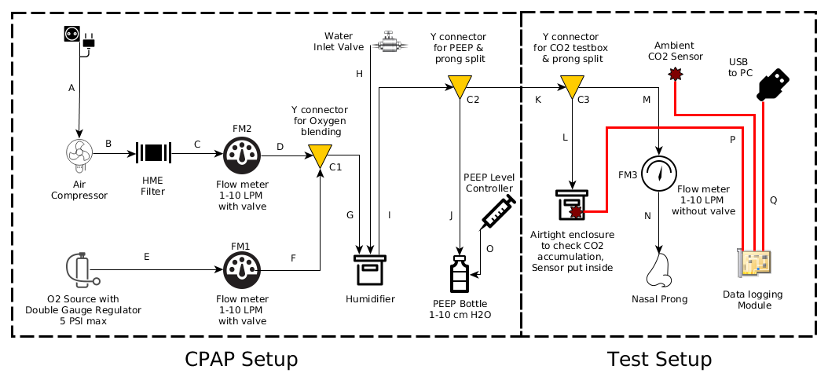

Fig:1 - Test setup

Data acquisition firmware is implemented on arduino development board. The board is connected to the PC and constantly pushing the sensor data through USB serial port which is being monitored by a python script at the PC side to append the data inside a log file for further analysis.

Python setup guide & usage instructions on the python script is explained in the separate document.

For a detailed BOM with part number & legends (w.r.t. Fig:1), please refer to the attached BOM document.

The default file extension of the log file is .csv & can be opened with any spreadsheet application like MS Excel or LibreOffice Calc etc.

Conclusion:

The log files are extracted & plotted to analyse the CO2 levels inside the breathing circuit with respect to the ambient CO2 levels, thus helping us come to the conclusion.